FACULTY COURSE ALLOTMENT SYSTEM
TEAM MEMBERS:
1.NARUKULA.SUDHARSHANA(25A31A0521)(TEAM LEADER)
2.VEEDHI.HARSHITHA(25A31A0528)
3.MONDI.S.S.V.THARUN(25A31A0545)
4.PAMPANA.SANDEEP KIRAN(25A31A0552)

GUIDED BY:
MR.G.VIJAY KUMAR
ASSISTANT PROFESSOR
CSE DEPARTMENT
PRAGATI ENGINEERING COLLEGE(A)
SURAMPALEM

Faculty Course Allotment System

Abstract
The Faculty Course Allotment System is a web-based application designed to automate and simplify the process of assigning courses to faculty members in educational institutions. Traditionally, course allotment is done manually, which is time-consuming, error-prone, and difficult to manage, especially when handling faculty preferences, workload balance, and subject expertise.
This system provides an efficient and transparent solution by collecting faculty details such as qualifications, experience, subject specialization, and course preferences. Based on predefined rules and constraints, the system automatically allots courses to suitable faculty members while ensuring optimal workload distribution. It also allows administrators to modify, update, and approve allotments easily.
The proposed system reduces manual effort, avoids conflicts, improves accuracy, and saves time for academic administrators. It ensures fair and effective utilization of faculty resources and enhances overall academic planning. The Faculty Course Allotment System is scalable, user-friendly, and can be adapted to meet the requirements of different educational institutions.
Project Title
Faculty Course Allotment System
1. Problem Statement
In many educational institutions, the process of allotting courses to faculty members is carried out manually. This traditional method is time-consuming, inefficient, and often leads to errors such as workload imbalance, subject mismatch, and conflicts in scheduling. Managing faculty preferences and qualifications manually becomes difficult as the number of courses and faculty increases. Hence, there is a need for an automated system to ensure accurate, fair, and efficient course allotment.
2. Objectives of the Project
To automate the faculty course allotment process
To reduce manual work and human errors
To allot courses based on faculty expertise and preferences
To ensure balanced workload distribution among faculty
To provide easy modification and monitoring for administrators
3. Proposed System
The proposed Faculty Course Allotment System is a computerized system that stores faculty and course details in a database. The system processes faculty qualifications, experience, and preferences to automatically assign suitable courses. Administrators can view, update, and finalize the allotment efficiently. This system improves accuracy, transparency, and speed.
4. Existing System
Manual allotment using papers or spreadsheets
Time-consuming and error-prone
Difficult to manage faculty preferences
No centralized database
Poor scalability
5. Advantages of the Proposed System
Saves time and effort
Reduces errors and conflicts
Ensures fair course allocation
Easy to update and manage
Improves efficiency and transparency
6. Modules of the System
Admin Module
Login authentication
Add/update faculty details
Add/update course details
Generate and modify course allotment
Faculty Module
Login
View allotted courses
Submit course preferences
Course Management Module
Maintain course information
Assign courses to faculty
Allotment Module
Automatic course allocation
Workload balancing
7. Software Requirements
Front End: HTML, CSS, JavaScript
Back End: PHP / Java / Python
Database: MySQL
Operating System: Windows / Linux
8. Hardware Requirements
Processor: Intel i3 or above
RAM: Minimum 4 GB
Hard Disk: 40 GB or more
Internet connection
9. Applications
Colleges and Universities
Academic institutions
Training centers
10. Conclusion
The Faculty Course Allotment System provides an effective and reliable solution for managing course assignments in educational institutions. By automating the allotment process, the system minimizes errors, saves time, and ensures fair distribution of courses among faculty members. This project enhances academic planning and improves institutional efficiency.

The below is architecture: Faculty Course Allotment System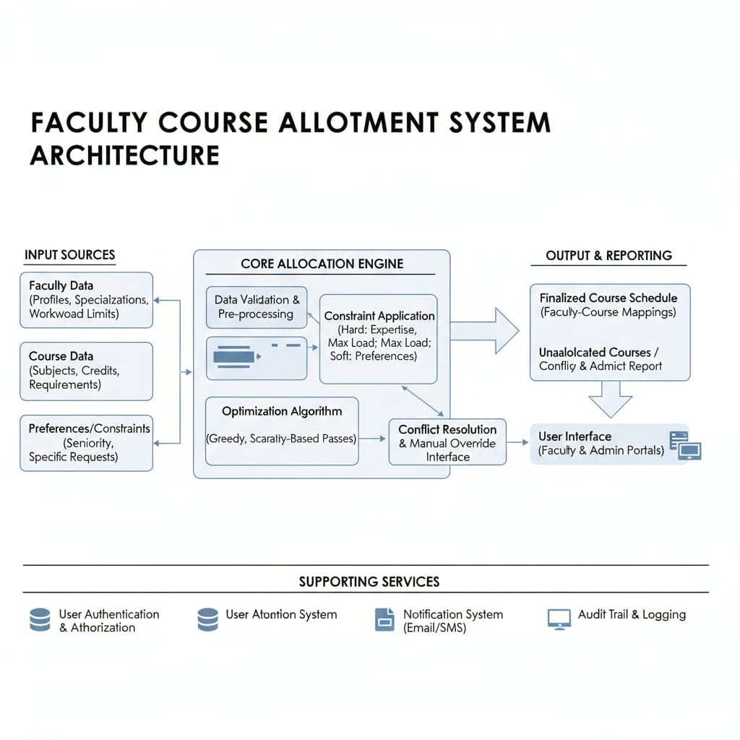

flowchart:
